Top of Form
Bottom of Form
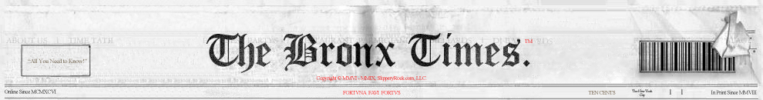
New York, NY, Thursday, October 29, 2015
Home | News | Business | Bronx Leads All Boroughs In Court Evictions Of Businesses, Up 30%

Bronx Leads All Boroughs In Court Evictions Of Businesses, Up 30%
10/29/2015 10:46:00 By Peter Milosheff, viewed 25 times.
Font size:
October 16, 2015
Dear Hon. Elected Representatives of the Borough of Bronx,
Recently a community forum was held in the Bronx on the topic of “Solutions to Save Bronx Small Businesses.” Last year Bronx lead all boroughs with increases of court evictions of commercial businesses; up 30% from previous years. With years of unchecked real estate speculation spreading throughout the city resulting in dire consequences for business owners when their leases expire, the many sponsors listed above realized the time had come for an honest debate on solutions to end the increasing number of Bronx small businesses forced to close due solely to demands for exorbitant rents.
Soon, proposals will be presented in the City Council and Bronx business owners have requested we make our elected officials aware that while high rent increases are the primary cause of successful businesses to be forced to close, at the root of their crisis is the unfair and one sided commercial lease renewal process which has created instability, loss of jobs, slowed growth, lowered wages, raised prices, stopped job creation, and resulted in business owners having no predictability of their future.
In light of this, four major issues facing Bronx businesses must be resolved in any solution to stop the closing of long established successful businesses and return them again to stability and prosperity which will allow them to do what they do best: create jobs. Those four issues for resolution must be included in any legislation are as follows:
- End outrageous rent increases: Commercial tenants have no rights whatsoever. Their investment and future is at the mercy of their landlords. Business owners are victims of decades of manipulation and speculation of the free market, rent gouging, banks bidding against franchises for prime space, warehousing store fronts sometimes for years, flipping property with commercial space in it and just plain greed. All results in Bronx businesses not able to compete to gain reasonable lease terms. The rents demanded today in Bronx have no relationship to actual landlord's costs or a reasonable return for the landlord.
- Stop illegal extortion of small business owners: Some unscrupulous landlords or their agents, are taking advantage of the speculative market and the fact the tenants have no rights by demanding "cash under the table" accompanied by the threat to throw out the tenant when their lease expires. While this trend has increased and primarily targeted immigrant owners, non-immigrant owners are now also being extorted.
- End short-term leases: The global real estate speculation taking place in NYC has resulted in a dramatic decline in the length of leases being offered to small business owners. The reason for short-term leases and their appeal to real estate speculators, is it enables them to remove tenants quickly. The landlords want to be better positioned to sell their buildings if the opportunity arises, while others are waiting for deep pocket franchises willing to pay huge increases for their space. Small business owners cannot plan for their future with short leases, can’t hire new workers and cannot pay higher salaries. Short leases are job killers.
- End oppressive landlord pass-alongs: With commercial tenants having no rights, the landlords are forcing the tenants to pay for their taxes and ‘other costs’ for which the landlords are legally responsible. These passalongs have in many cases put Bronx businesses past the tipping point in terms of ever hoping to make a reasonable profit. How can a business survive when they have no rights to negotiate fair lease terms and are forced to pay exorbitant rents in addition to paying the landlords’ growing taxes along with the high costs of operating a business in NYC? No immigrant owners came to Bronx investing their life’s savings and working day and night with the goal of ending up working for their landlord.
Upon careful review of all the proposals, and listening to the business owners, the panel unanimously recommend the passage of the Small Business Jobs Survival Act (File #: Int 0402-2014). While other proposals claim to be a solution to stop the closing of businesses, they all would keep the anti - small business status quo. Not one other proposal would stop any closings nor would they seriously address even one of the four major problems facing Bronx businesses. Whereas, the SBJSA is a real solution and the only one which addresses all four of the major problems facing Bronx businesses.

Top of Form

